Figures and tables:
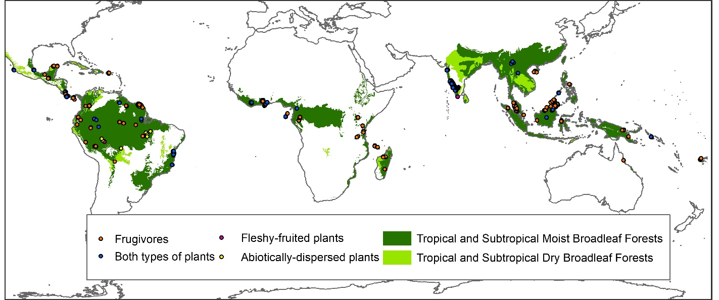
Figure 1. Distribution of the sites used in the analysis for the taxonomic groups of interest.

Table 1. Number of studies, sites and species (spp.) within each LUI category and for the three response variables.
Land Use and Intensity |  | Total abundance model |  |  | Species richness model |  |  | Simpson´s diversity
Predominant Land use | Use intensity | Spp. | Sites | Studies | Spp. | Sites | Studies | Spp. | Sites | Studies
Primary vegetation | Minimal use | 1030 | 1040 | 69 | 1134 | 1152 | 71 | 1025 | 773 | 60
Primary vegetation | Light-Intense use | 464 | 618 | 35 | 560 | 666 | 37 | 457 | 345 | 28
MSV | All uses | 356 | 266 | 22 | 518 | 150 | 23 | 353 | 104 | 19
ISV | Minimal use | 551 | 185 | 31 | 710 | 218 | 33 | 550 | 155 | 29
ISV | Light-Intense use | 277 | 235 | 15 | 310 | 239 | 13 | 272 | 159 | 11
YSV | All uses | 539 | 336 | 26 | 680 | 429 | 28 | 537 | 213 | 24
Plantation forest | Minimal use | 386 | 190 | 17 | 499 | 495 | 23 | 385 | 166 | 16
Plantation forest | Light-Intense use | 414 | 805 | 21 | 471 | 1000 | 27 | 413 | 478 | 20
Pasture | All uses | 167 | 283 | 13 | 198 | 283 | 13 | 163 | 114 | 10
Cropland | Minimal use | 294 | 116 | 10 | 383 | 130 | 11 | 293 | 96 | 9
Cropland | Light-Intense use | 132 | 206 | 5 | 149 | 207 | 6 | 132 | 102 | 5

Table 2. Comparison between the more complex models (initial models) and their simplified versions. I divided the table by the type of simplification performed (shown in italics), and then further subdivided it by the model assessed. The initial R² shows the conditional R² (marginal R²) for the more complex models, while the simplified R² represents the same but for the simplified versions. X² values show the results of the likelihood-ratio tests done to compare the fit between the initial and the simplified models.
Model | Initial R² | Simplified R² | X² | Degrees of freedom
Land-use intensity collapse
Total Abundance | 56.25(4.61) | 55.41(4.35) | 22.401* | 12
Species richness | 78.03(13.03) | 74.38(7.80) | 284.63* | 12
Simpson´s diversity | 67.89(7.55) | 66.93(5.50) | 95.68* | 12
Model | Initial R² | Simplified R² | X² | Degrees of freedom
Dispersal syndrome collapse
Total Abundance | 56.25(4.61) | 55.16(3.33) | 88.679* | 11
Species richness | 78.03(13.03) | 69.08(5.56) | 1421.8* | 11
Simpson´s diversity | 67.89(7.55) | 63.25(4.30) | 276.6* | 11
*P<0.05

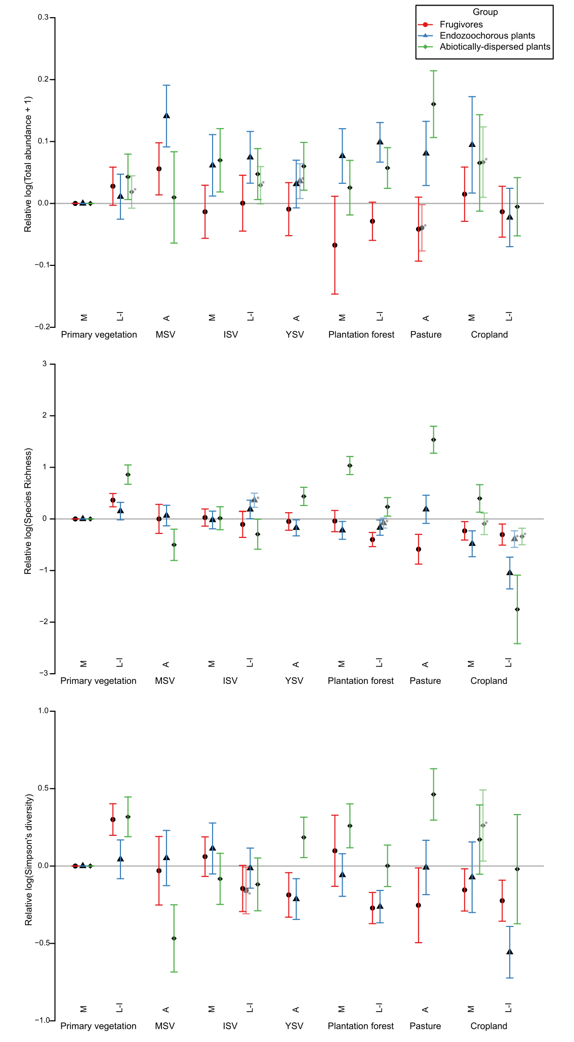
Figure 2. Relative total abundance, species richness and Simpson´s diversity of the taxonomic groups of interest in different land-use classes and intensities (M = minimal use, L-I = light-intense use, A = All use intensities). Changes in response variables are measured relative to Primary vegetation minimal use. Error bars show 95% confidence intervals for each coefficient. Also shown are robust estimates (shown in lighter colour and marked with an asterisk), when these were substantially different from the coefficients of the initial models.

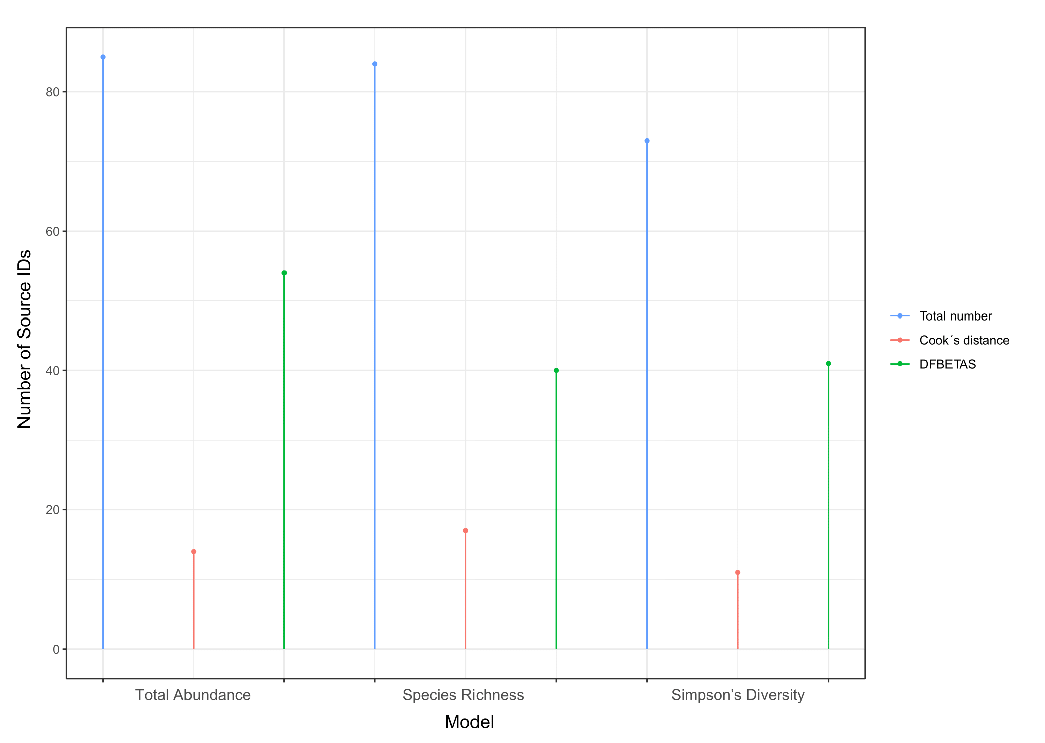
Figure 3. Total number of Sources used in each model, compared to the number of influential Sources. Influential sources were identified with the Cook´s distance and DFBETAS criteria. Cook´s distance measures substantial changes in all coefficient estimates of the model, while DFBETAS measures changes in single coefficients. For this last statistic, I included sources that overly influenced at least one coefficient.

